DOCUMENT AND ARCHIVE MANAGEMENT

Function: | Prepared by: | Reviewed by: | Approved by:
Department: | Quality Assurance | Systems and cybersecurity | Quality Assurance
Name: | Ivan Perez | David Pozo | Fernando Pozo
Signature:
Date:

Valid until: | 05/07 /2028

DOCUMENT HISTORY
VERSION | CAUSES OF MODIFICATION | EFFECTIVE DATE | REPLACES (CODE, REVISION)
01 | INITIAL EDITION | 07/02/2024 | N/A
02 | Update to detail the nomenclature of the PNTs and their mission, according to AC-030/24 | 03/20/2024 | PNT-001.01
03 | Update of SPIKA departments, modification of point 5.2.1 and addition of points 5.3 and 5.4 to align the procedure with the provisions of Article 10 of Regulation (EU) 2017/745 of the European Parliament and of the Council of 5 April 2017 on medical devices, as regards their content. | 08/20/2024 | PNT-001.02
04 | File content update according to Article 10 with regard to Annex II and III of Regulation (EU) 2017/745. | 09/26/2024 | PNT-001.03
05 | Change of Spika departments, content change to move from paper to digital. Expansion of document nomenclature to accommodate those created in the ISMS. | 02/06/2025 | PNT-001.04
06 | Inclusion of translation management, changes in document retention periods | 05/07 /2025 | PNT-001.05

Content
1. Objective 5
2. Scope 5
3. Responsibilities and departments affected 5
4. Definitions and Acronyms 6
5. Procedure 7
5.1. General document management 7
5.1.1. Preparation 8
5.1.2. Codes and review and approval flow 8
5.1.3. Document Coding and Mission 9
5.1.4. Distribution 10
5.1.5. Reading recognition 11
5.1.6. Obsolete documents 11
5.1.7. Backup documentation 12
5.1.8. Revision date 12
5.1.9. Model Management 12
5.1.10. Database 13
5.1.11. Document translations 13
5.2. File 14
5.2.1. Contents of file 14
5.2.2. Custody of documentation 18
5.2.3. File system and location 19
5.2.4. Withdrawal of documentation 19
5.2.5. Documentation Preservation 19
5.3. Quality Management System 20
5.4. Post-marketing surveillance and monitoring 20
6. Distribution of Procedure 20
7. Annexes 20
8. Related documentation 21
9. Formation 21
Guide for the preparation of procedures 22
Guide for the preparation of procedures 27
Document Distribution and Withdrawal Record Booklet 35
Office review notebook 36

- Aim
The purpose of this procedure is to establish a system that ensures that the documentation that is in force and to which authorized users have access is the most up-to-date and that all modifications made to the processes and documentation are promptly notified to the appropriate personnel in each case, thus ensuring a correct flow of information between personnel and constant maintenance of their training.
Guidelines for preparing procedures for the initial drafting and/or updates of all SpikaTech documents are available in Annex 1 of this procedure.

- Scope
This procedure applies to all SpikaTech documents except those listed below:
DOCUMENT | TITLE OF THE PROCEDURE THAT MANAGES IT
Nonconformities/deviations | Non-conformity management
Exchange Controls | Change control management
Claims | Claims management
Corrective and Preventive Actions | Management of corrective and preventive actions
Others: | There may be other documents that are specified in the management's own PNT.

- Responsibilities and departments affected
It is the responsibility of all SPIKA TECH employees to prepare and oversee the management of documents.
The Responsible Technician , or the person delegated by him/her, is responsible for supervising the management of documents, as well as safeguarding them and keeping the distributed copies up to date.
The affected departments are those indicated in the following table:
Department | Apply
 | Yeah | No
Address | ☒ | ☐
Environment | ☒ | ☐
Quality Assurance | ☒ | ☐
Systems and Cybersecurity | ☒ | ☐
Research and Development | ☒ | ☐
Marketing and Sales | ☒ | ☐
Management | ☒ | ☐

- Definitions and Acronyms
- PNT : Standard Operating Procedure.
- GF : Manufacturing Guide
- TR : Technical Manager
- DO : Director of Operations
- DG : Director General
- E . Specification
- PV : Validation Protocol
- PC : Qualification Protocol
- Controlled Copy: is the copy generated from copy number 1 that is considered the original and is kept in the file as the original.
- Working Copy : is the copy generated from copy number 1 of a document for data recording, see for example manufacturing or packaging guides.
- Unauthorized or uncontrolled copy: a copy of any document whose distribution is not subject to control.
- Obsolete version: any document that is replaced by a new version of the same document.
- Current document: A document that has been approved after passing through a controlled documentation review-approval process and on which the relevant personnel have been trained. It is therefore the most up-to-date version and is accessible to those users who have already been trained on it.
- Review: Verification that what is written corresponds to what is established. A document's reviewer will be a person with sufficient knowledge of the applicable topics. A document may have one or more reviewers from one or more departments.
- Approval: Consideration of the prepared document as valid or acceptable. Approval also involves reviewing it in whole or in part. Approvers will be department heads (or staff to whom they delegate) whose work may be affected by the content or whose knowledge of the information contained in the document is required.

- Procedure
  - General document management
All standard operating procedures, protocols, specifications, etc., will not be effective until they have been previously reviewed and approved by the appropriate individuals. Spika Tech's quality management system will be digitally stored in the company's shared space.
The distribution of controlled copies will be made by recording them in the electronic controlled copy registration box, following the format in Annex 3 .
If distribution to third parties is required, it will be sent by email with acknowledgment of receipt in all cases. These must be kept as evidence of delivery to the third party. If no response is received from the third party within 15 days, the document will be considered approved by them.

    - Elaboration
The guide indicated in Annex 1 and the PNT Template indicated in Annex 2 will be used .
When necessary, any Spika Tech employee may request the Responsible Technician or the person they delegate to provide the template for the document they need to prepare in an editable format, as well as the document code. Documents may include annexes, the format of which is already included in the procedure template.
All documents will start at revision 01, with no versions 00 existing under any circumstances.
The author of the document will be responsible for requesting the coordination of reviewers and approvers to carry out their task. Once signed by all, the document will be delivered to the Responsible Technician or the person they delegate for document management.

    - Codes and review and approval flow
In general, the provisions of this table will be followed for the different types of documents; however, the review and approval boxes may be expanded depending on the type of document in order to ensure the best review and approval:
DOCUMENT | CODE | AUTHOR | CONDUCTOR | APPROVER
Specs | AND | TR | DO | -
Quality Management System Procedures | PNT | TR/DO/ | DO/TR/ others | DG
Specific procedures | ESP | Any department | TR/DO/others | DG/DO/TR
Validation, qualification or any other type of protocols | PR | Third Parties/TR/ Others | TR/DO | DG/DO/TR
Documents will be named according to the table code, followed by a hyphen XXX , a consecutive number, a period, and the version YY, starting with 01, plus the title. Example:
PNT-001.01 DOCUMENT AND ARCHIVE MANAGEMENT , corresponds to procedure 001 in its version 01.

    - Codification of documents and mission
The documents handled in Spika Tech are coded as follows. The following table indicates the mission of each of them, taking into account that in all cases XXX refers to three consecutive numbers and YY is the version, always starting with 01:
CODE | DESCRIPTION | MISSION
PNT-XXX/YY | General procedures | These are standardized operating procedures of a general nature that lay the foundation for the quality management system, such as document management, non-conformity management, etc.
ESP-XXX/YY | Specific procedures | These are standard operating procedures that describe specific activities in the work methodology and that, as a general rule, do not apply to the entire organization but rather to a specific department, since they describe how to carry out specific and exclusive tasks of a department.
E -XXX/YY | Specs | These are documents that list the requirements that products must meet, clearly indicating the value or acceptance criteria, for example, size in cm.
PR-XXX/YY | Validation protocols | These are documents generated as part of validations and specifically contain the battery of tests to be performed in the validation exercise, as well as the acceptance criteria in each case.
MQ-XX/YY | Quality Manual | It is the parent document of the quality management system.
PLT XXX.YY | Policy | Basic guidelines for information security
NRM XXX.YY | Rule | General rules for the use of information security
PRO XXX.YY | Procedure | Processes of how to perform certain specific actions
RGS XXX.YY | Record | Records where information about the current status of different areas is stored
ADR XXX.YY | Risk analysis | Risks affecting Spika Tech and how they have been addressed

    - Distribution
Once the document is approved, after being duly reviewed and approved according to the table shown in section 5.1.2 ., the following actions will be triggered:
- Delivery of the document to the Responsible Technician or the person he delegates
- The responsible Technician or the person he delegates must:
  - Record the document in the copy logbook
  - Upload copy 1 of the document to the shared space for staff reading.
- The departments involved in the document have 15 days to read and/or review the document and sign and date the reading log, which will accompany the procedure, and/or complete the corresponding questionnaire.
- After 15 days, the Responsible Technician or the person designated by him/her must verify that all applicable personnel have read or been trained in the procedure. In the following cases:
  - Negative: People who have not read/formulated the document will be contacted and will be given a one-week extension.
  - Affirmative: the document will be considered valid for its entry into force.

    - Reading recognition
In the case of Standard Operating Procedures (SOPs), the corresponding departments must read and understand them. A digital form (Google Forms) will be used.
This form will record that the person has read the procedure, automatically recording their full name, code, version, and title of the procedure read.

    - Obsolete documents
When a document becomes obsolete because a new version has been generated, the Responsible Technician or the person delegated by him/her must:
- Take the controlled copy logbook of that version of the document and proceed to remove all of them.
- Delete the copy from the shared space and move it to the obsolete folder.

    - Backup documentation
By archiving documentation, the Technical Manager or the person designated by him or her keeps all procedures up to date. Likewise, all current documents are stored on SPIKA's information storage server: Spika Tech - Home

    - Review date
All SpikaTech procedures will be valid for three years from the date they come into effect.
This 3-year period may be shortened if a circumstance or change occurs beforehand that makes it necessary to review and modify it.
It is recommended that changes made to a document for the purpose of issuing a new version be indicated in italics. This is intended to facilitate quick viewing of the changes made compared to the previous version. If the entire document is modified, the use of italics may be avoided, indicating this in the reasons for the modification.
If the three-year period is reached and the procedure does not require review because the conditions explained in the document have not changed, an ex officio review may be carried out. To do this, fill out the corresponding space in the ex officio review form, following the format in Annex 4. This will explain the reason for the extension. Up to two ex officio reviews may be issued, each valid for three years. The new effective date must be stamped on all pages of the original, as well as on the cover of the document in the "valid until" box. In these cases, it will not be necessary to distribute controlled copies.

    - Model management
The templates will always be included as part of the procedures, serving as a guide for preparing the documents. The responsible technician or the person they delegate will have editable templates for the documents and will make them available to interested parties at all times.
    - Database
The Technical Manager or the person designated by him or her will maintain a database with the codes, titles, effective dates, and revisions of all documents. To formalize this database, a signed and dated copy will be issued for each modification.

    - Document translations
When Spika Tech medical devices are marketed in countries whose official language is not Spanish, documents intended for the user or healthcare professional (instructions for use, labels, manuals, technical sheets, etc.) must be translated into the corresponding language of the destination country.
The Responsible Technician or the person he delegates will be responsible for:
- Ensure the technical accuracy of translations, including review by competent personnel or qualified translators.
- Keep the translated versions as part of the technical file.
- Identify translated documents using the same code as the original document plus the ISO 639-1 language code (e.g., IFU-012.01_EN, IFU-012.01_FR).
- Ensure that they are distributed together with the product in the corresponding country.
Translations will be subject to the same documentary control as other controlled documents. In the event of discrepancies, the Spanish version will prevail as a technical reference.

  - Archive
It is important to archive the documentation generated from activities related to Medical Devices correctly and securely, ensuring rapid access and ensuring that the documentation is complete, controlled, and restricted.

    - File content
The documentary archive will contain the following:
- Documentation relating to the quality system and specifications of each product.
- Documentation that allows for tracking of products within the production and control chain.
- Documentation that allows understanding of the product's design and features.
- Documentation related to marketing, containing the product's identification data (trade name, version), production date, delivery to distributors or health centers
- Documentation relating to experience gained from the use of the products, including that derived from the surveillance system, as well as complaints and market returns.
- Complete technical documentation, including the technical file, clinical evaluation, and risk management in accordance with harmonized standards, aligned with Annex II of Regulation (EU) 2017/745.
- Risk management procedures in accordance with the applicable harmonized standard.
- Procedures that guarantee product traceability, including a unique product identification system.
- Technical documentation on post-marketing surveillance, aligned with Annex III of Regulation (EU) 2017/745.

The following table lists the type of documentation, support and retention period:

SPECIFIC DOCUMENTATION FOR MEDICAL PRODUCTS (* ⁶ )
TYPE OF DOCUMENT | MEDIUM | FILE MANAGER | ARCHIVE PERIOD
Approved types and copies of EC type-examination certificates (note 1) | Paper and/or electronic | Quality Assurance | 10 years
Quality System adaptation projects, including assessments and reports from the Notified Body | Paper and/or electronic | Quality Assurance | 10 years
Periodic inspections and assessment/inspection/test reports from the Notified Body | Paper and/or electronic | Quality Assurance | 10 years
EU Declaration of Conformity (note 2) | Paper and/or electronic | Quality Assurance | 10 years
Product technical documentation (note 3)  -Product description and specifications, including variants and accessories  - Information to be provided by the manufacturer  - Information on design and manufacturing  - General safety and operating requirements  - Benefit-Risk Analysis and Risk Management  - Verification and Validation of products | Electronic | Quality Assurance | 10 years
Personal documentation:  - Job descriptions  - CVs  - Signature recognition  - Declaration of those responsible to the Health Authorities | Paper and/or electronic | Quality Assurance | (3)  (For active staff only; documentation for staff on leave will be kept for 5 years)
Training documentation:  - Training plans  - Records of internal and external training received | Paper and/or electronic | Quality Assurance | (3)  (For active staff only; documentation for staff on leave will be kept for 5 years)
Procedures and specifications | Paper and/or electronic | Quality Assurance | (3)
Quality Manual | Paper and/or electronic | Quality Assurance | (3)
Documentation of the quality system of subcontracted third parties | Paper and/or electronic | Quality Assurance | (2)
Supplier quality system documentation | Paper and/or electronic | Quality Assurance | (2)
Audit plans, audit reports (internal and external), third-party quality questionnaires | Paper and/or electronic | Quality Assurance | (3)
Quality System Documentation, Improvement Plans | Paper and/or electronic | Quality Assurance | (2)
Non-conformities, Corrective and Preventive Actions and their follow-up | Paper and/or electronic | Quality Assurance | (2)
Claims for Quality Defects | Paper and/or electronic | Quality Assurance | (2)
Non-conformities | Paper and/or electronic | Quality Assurance | (2)
Adverse / potential incidents | Paper and/or electronic | Quality Assurance | (3)
Validation Documentation | Paper and/or electronic | Quality Assurance | (3)
Documents related to customers, purchases, orders , etc. | Paper and/or electronic | Sales | (2)
Certificate of approval and release of products | Paper and/or electronic | Quality Assurance | (1)
Production documentation | Paper and/or electronic | Quality Assurance | (1)
Product distribution registration | Paper and/or electronic | Sales | (2)
Withdrawals | Paper and/or electronic | Quality Assurance | (3)
Post-marketing technical documentation :  Post-marketing surveillance plan (As set out in Article 84 of Regulation (EU) 2017/745 )  - Periodic updated safety reports (as set out in Article 86 and 85 of Regulation (EU) 2017/745) | Paper and/or electronic | Quality Assurance | (3)

For each medical device manufactured, a batch file will be maintained with all the documentation generated to demonstrate compliance with regulatory requirements. This also includes documentation to ensure the traceability of medical devices. The archiving period is 10 years:
- Manufacturing protocol (Production documentation).
- Quality control/tests performed ( PNT-016 approval, rejection and product release )
- Documentation to ensure product traceability (Product Distribution Record).
- Instructions for use and labeling.
- Release certificate signed by the Technical Manager.
- EU Declaration of Conformity.

(Note 1) EC type-examination is the procedure by which a Notified Body checks and certifies that a representative sample of the production under consideration complies with the provisions of Directive 93/42/EEC relating to medical devices and its updates.
(Note 2) The Declaration of Conformity is the procedure by which the manufacturer ensures and declares that the products in question comply with the provisions of Regulation (EU) 2017/745 applicable to them.
(Note 3) Technical file containing all the product's technical documents and essential requirements. These documents define the complete production process, including risk management and analysis, testing and material specifications for the intermediate and finished product, details of the product's packaging and labeling, instructions or user manuals, and the regulatory requirements checklist completed by the manufacturer, as well as its declaration of conformity.
The following corresponds to the conservation time:
File code | Meaning / Retention period
(1) | Documentation relating to production batches is archived for up to 2 years after the date of release of the product batch.
(2) | Product-related records are kept for up to 10 years from the date the product was last placed on the market.
(3) | Documentation kept indefinitely except for exceptions indicated in the corresponding PNTs of each registry.

    - Custody of documentation
Documentation derived from the quality management system is considered confidential, and access to it is restricted to authorized individuals, who are responsible for its handling and review. It may not be photocopied, reproduced, or transferred to any other person without explicit reason.
The following persons are authorized to access said documentation:
- Technical Manager
- Director of Calida
- SPIKA Address
No person other than those mentioned above will have access to this documentation, with the following exceptions:
- Pharmaceutical Inspectors from the Ministry of Health, Social Services and Equality, with prior accreditation and accompanied by one or more authorized persons.
- Internal auditors of the Company, duly accredited and accompanied by one of the persons authorized to have access.
- External auditors of the Company, with prior authorization from the Technical Director and accompanied by one of the persons authorized to have access.
- Inspectors from an official body, specifically authorized by the Spanish Administration for this purpose, with an explicit reason and accompanied by one of the persons authorized to access them.

    - File system and location
Documentation may be filed electronically:
- Electronic Support: Spika Tech - Home

    - Withdrawal of documentation
Document control is essential for maintaining the quality management system. The responsible technician or the person designated by them will maintain custody; only they will have access to the documentation file. If necessary, the responsible technician or the person designated by them will deliver the document.

    - Preservation of documentation
SPIKA TECH will retain documents for the period indicated in the table in section 5.2.1. When the retention period expires, the Technical Manager must authorize their destruction.

  - Quality Management System
SPIKA TECH will establish, document, implement, maintain and improve a quality management system that meets the requirements of Regulation (EU) 2017/745

  - Post-marketing surveillance and monitoring
The manufacturer will implement and maintain a post-marketing surveillance and monitoring system that allows for the collection, evaluation, and analysis of data on the product's performance and safety once it has been marketed.

- Distribution of the Procedure
Staff members in the departments listed in Section 3 (Responsibilities and Affected Departments) must be provided with a copy of this procedure. In addition, controlled copy No. 1 will be submitted to the Archives for paper archiving.
Controlled copies to be issued:
Controlled Copy No. | Departments
1 | Archive
- Annexes
NO. / REV. | QUALIFICATION
1/01 | Guide for the preparation of procedures
2/01 | Guide for the preparation of procedures
3/01 | Document Distribution and Withdrawal Record Book
4/01 | Office review notebook

- Related documentation
Code | Qualification
MQ-01 | Quality Manual
N/A | Regulation (EU) 2017/745 of the European Parliament and of the Council on medical devices, amending Directive 2001/83/EC, Regulation (EC) No 178/2002
N/A | Regulation (EC) No 1223/2009 and repealing Council Directives 90/385/EEC and 93/42/EEC

- Training
This version requires that the affected departments indicated in section 3 receive the training indicated below:
Mark with an X | Type of training
☒ | Theoretical (reading and understanding of the procedure)
☐ | Theoretical – Practical (If you select this option, contact the Responsible Technician)

Annex 1_VERSION_01

Guide for the preparation of procedures
- Template to be used: To draft SPIKA TECH procedures, follow the template indicated in Annex 2 of this PNT. Request the template from the Responsible Technician or the person they delegate.
- Typography:
Typography is divided into several fonts depending on their use. Their styles and usage can be configured in the styles section of the toolbar, making it easier for you to use each font directly.
The sources are as follows:

 | Use | Name in Styles
EXO | Cover title | Cover title SP
Trebuchet | Titles and subtitles within the document content | Title Cont.1 SP  Subtitle Cont1. SP
Roboto | Memory or content of documents | Memory.1 SP

The font size will vary depending on the document, title name, etc. However, generally, titles will have a size of 16, subtitles 14, and document memory 12.

- Cover page: This must include the header, the title of the document, and a box below this table indicating the validity date. The latter must be left blank during document preparation.
- Headers: configured in table format, it includes the logo where the following must be indicated: document title, code and version.
- Footer: pagination is included in X and Y format, on the right side, indicating the version.
- Margins and spacing:
- Sup and Inf: 1.5 and 1.25
- Left and Right: 1.91
- Lists and bullets:
- Lists and bullet points will have a left-aligned margin.
- It will consist of three options of Spika Tech's identifying color, and the individual will be able to choose the color as needed for the documentation.
- The circular symbol will be set as default.
- Paragraph style: Paragraphs must always be justified . There must be a default spacing of 8 pt between paragraphs . This may be the only exception in the table of contents.
- Color palette: as indicated below:
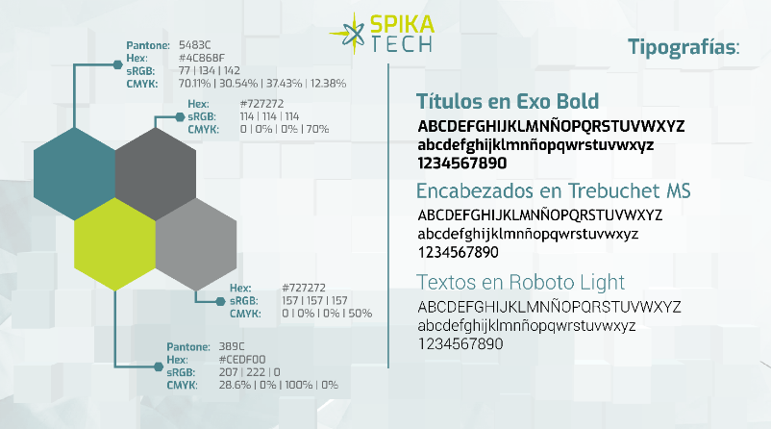

- Document history: This is the second page of every document after the cover page. It includes a table containing the version history, always sorted from lowest to highest, starting with version 1. You can add as many rows as necessary, but no rows should be left blank. This table contains:
- Version: Enter the version number.
- Reasons for modification: all changes made to the document must be indicated here. If it is the initial version, indicate: Initial edition.
- Effective Date: This box will be left blank when editing the document, and the Responsible Technician or the person delegated by the Technician will stamp the date when the document becomes effective.
- Supersedes: Reference must be made to at least the previous version that will be obsolete when the new version comes into effect and all documents that are obsolete by this new version.
- Table of Contents: All documents must have a table of contents that summarizes the sections of the document and the page where it is located.
- Minimum sections and content to include: following the template prepared, the following are available:
- Objective: To clearly and simply include the purpose of the PNT.
- Scope: Indicate the scope of the PNT, including processes, systems, equipment, products, etc. In addition, indicate if there are any items outside the scope of the procedure.
- Responsibilities and affected departments: At the beginning of the section, the departmental responsibilities must be clearly defined, and then there is a table to mark which departments the application applies to and should be distributed. In this table, simply mark the corresponding boxes with an X. The table shows the corresponding controlled copy numbers in each case.
- Definitions and acronyms: Include all definitions and acronyms that are necessary to understand the content of the procedure.
- Procedure: This is the main section of the document where all the information is explained and presented. At this point, if necessary, you can create as many subsections as required.
It is recommended (as shown in template 1) that the titles of Sections and Subsections (First and Second Level) be left-justified; while for subsections and subsequent subsections (Third Level and subsequent), if necessary, the author should use the indentation he or she deems appropriate. Annex 1_VERSION_01
It is also recommended to include diagrams, flowcharts, tables, and images throughout the procedure to make it easier for the user to understand the content.
- Attachments: When they exist, they must be referenced in this table. All attachments must be versioned starting with version 01.
- Reference documentation: All documents used to create the PNT should be listed here. If they are internal documents, the code will be indicated; if they are external, this is not required.
- Training: The type of training required for each version of the document is specified here. This training will be decided by the document author. Theoretical training, which consists of reading and understanding the document, is generally selected, or practical training may be selected, which will also require reading and understanding an additional record. This latter type of training will be performed when the changes in the version are sufficiently complex to require additional explanation.
For training courses with questionnaires, they will be mandatory for all global and general procedures and optional for specific ones, as they are highly detailed reference documents.
- Procedure distribution: In line with the responsibilities section, the table must be filled out with as many rows as the document has copies, according to section 3 of the template.
- Document writing: As a general rule, documents should be written in Spanish, although if applicable, they can be written in bilingual, with each paragraph first in Spanish and then in English. Use a different color for English; blue is recommended. Titles should be indicated in Spanish, followed by a sidebar in English.
It is recommended to use justified text on both margins, Roboto Lig font size 10-11, with 1.15pt line spacing.
It is recommended to provide the necessary spaces between paragraphs and sections to facilitate the user's reading and follow-through.
Language appropriate for the end user of the procedure should be used, along with a sufficient level of detail to allow for proper execution of the operation and avoid any confusion.
It is recommended that changes made to a document to issue a new revision/version be indicated in italics. This is intended to facilitate quick viewing of the changes made compared to the previous revision/version. If the entire document is modified, italics may be avoided, indicating this in the "Reasons for Modification" column of the "Document History" table included on the first page of the SOP.

Annex 2_VERSION_01

Guide for the preparation of procedures
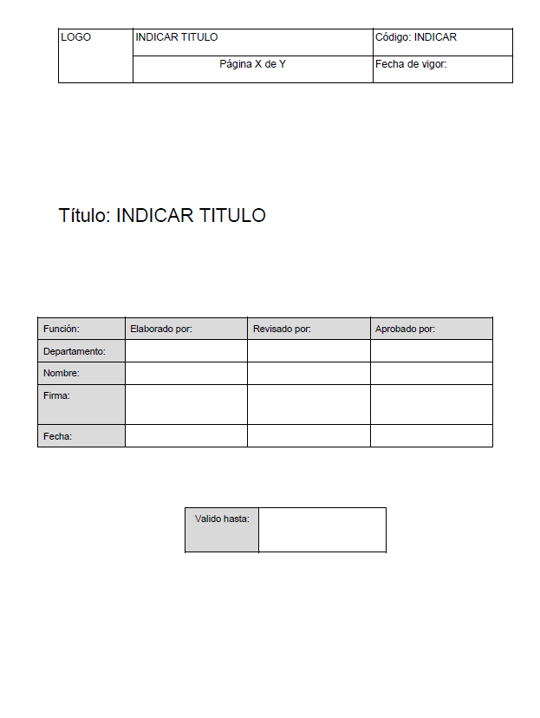
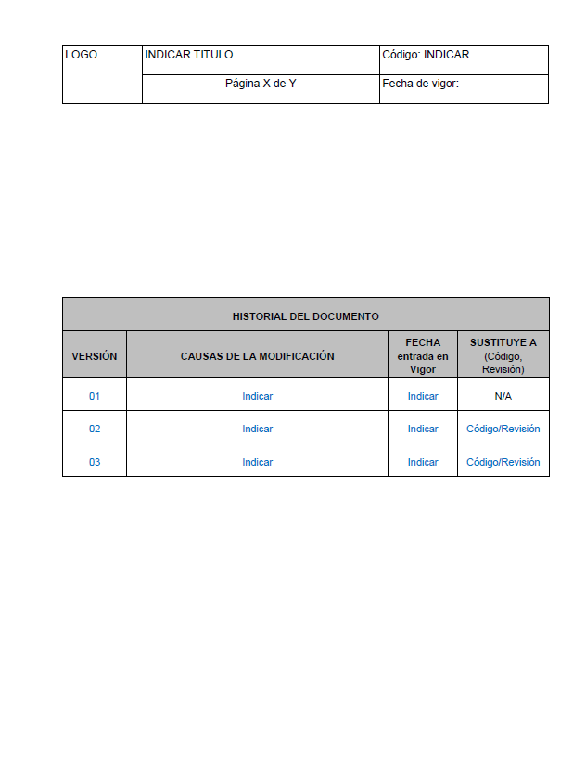
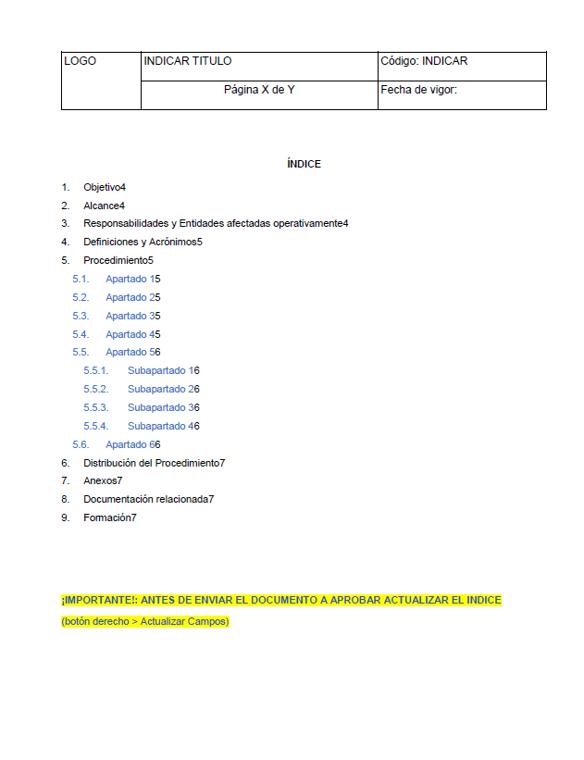

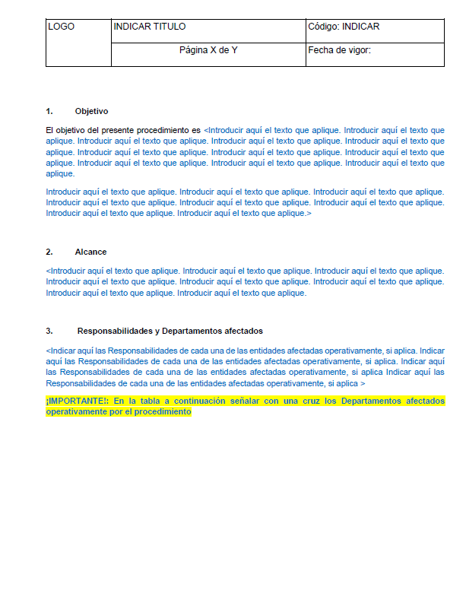

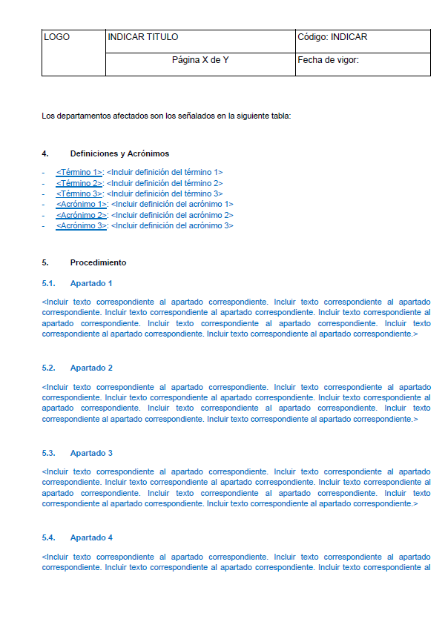
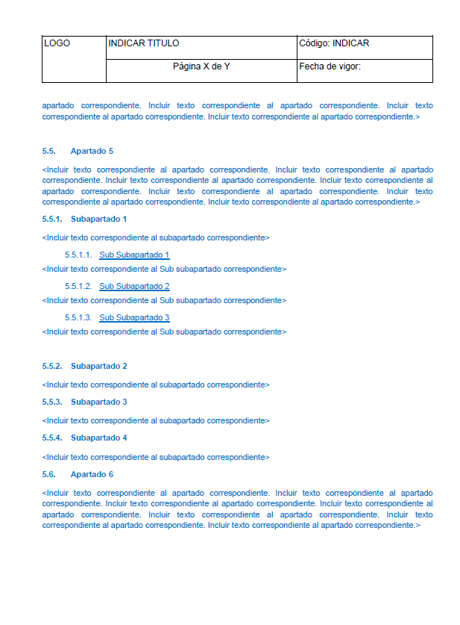

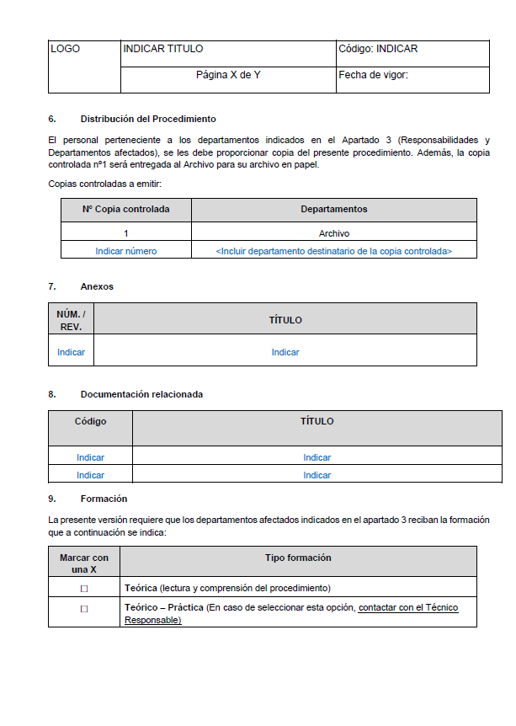
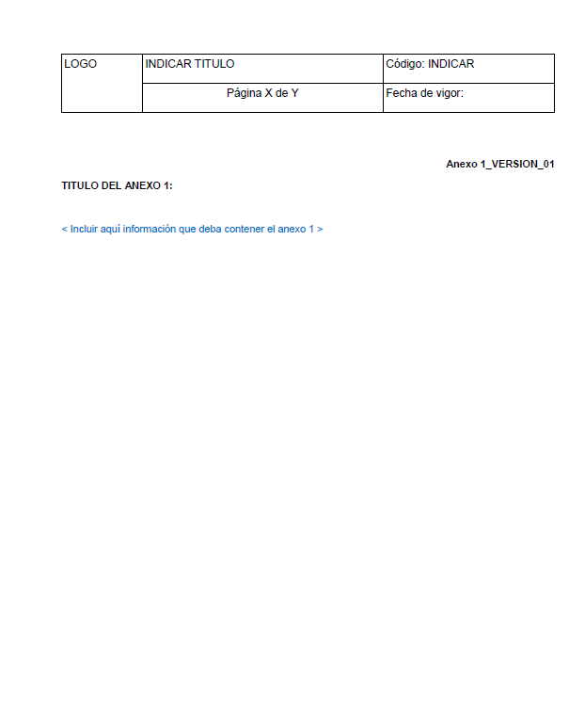

Annex 3_version01

Document Distribution and Withdrawal Record Book
DELIVERY, corresponds to the person who collects the copy.
In REMOVAL, this corresponds to the person who destroys the copy. Removing the copy corresponds to the review prior to the review of the copy submitted for completion by the Responsible Technician or the person designated by them.

Annex 4_version_01

Office review notebook
